//Programmer Name: Sharvil Prabhudesai 20co41

//Program title : FIFO

#include<stdio.h>

int main()

{

int i,j,n,a[50],frame[10],no,k,avail,count=0;

printf("FIFO Page Replacement Algorithm\n\n");

printf("\n ENTER THE NUMBER OF PAGES:\n");

scanf("%d",&n);

printf("\n ENTER THE PAGE NUMBER :\n");

for(i=1;i<=n;i++)

scanf("%d",&a[i]);

printf("\n ENTER THE NUMBER OF FRAMES :");

scanf("%d",&no);

for(i=0;i<no;i++)

frame[i]=-1;

j=0;

printf("\tref string\t page frames\n");

for(i=1;i<=n;i++){

printf("%d\t\t",a[i]);

avail=0;

for(k=0;k<no;k++)

if(frame[k]==a[i])

avail=1;

if (avail==0){

frame[j]=a[i];

j=(j+1)%no;

count++;

for(k=0;k<no;k++)

printf("%d\t",frame[k]);

printf("F\t");

}

else{

for(k=0;k<no;k++)

printf("%d\t",frame[k]);

}

printf("\n");

}

printf("Page Fault Is %d",count);

return 0;

}

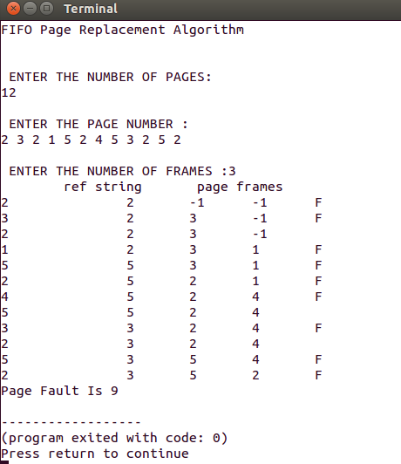

//Programmer Name: Sharvil Prabhudesai 20co41

//Program title : LRU

#include<stdio.h>

int main()

{

int q[20],p[50],c=0,c1,f,i,j,k=0,n,r,t,b[20],c2[20];

printf("LRU Page Replacement Algorithm\n\n");

printf("Enter no of pages:");

scanf("%d",&n);

printf("Enter the reference string:");

for(i=0;i<n;i++)

scanf("%d",&p[i]);

printf("Enter no of frames:");

scanf("%d",&f);

printf("Page no \t Frames\n\n");

q[k]=p[k];

printf("%d",p[k]);

printf("\t\t%d\n",q[k]);

c++;

k++;

for(i=1;i<n;i++)

{

c1=0;

for(j=0;j<f;j++)

{

if(p[i]!=q[j])

c1++;

}

if(c1==f)

{

c++;

if(k<f)

{

q[k]=p[i];

k++;

printf("%d",p[i]);

for(j=0;j<k;j++)

printf("\t\t%d",q[j]);

printf("\n");

}

else

{

for(r=0;r<f;r++)

{

c2[r]=0;

for(j=i-1;j<n;j--)

{

if(q[r]!=p[j])

c2[r]++;

else

break;

}

}

for(r=0;r<f;r++)

b[r]=c2[r];

for(r=0;r<f;r++)

{

for(j=r;j<f;j++)

{

if(b[r]<b[j])

{

t=b[r];

b[r]=b[j];

b[j]=t;

}

}

}

printf("%d",p[i]);

for(r=0;r<f;r++)

{

if(c2[r]==b[0])

q[r]=p[i];

printf("\t\t%d",q[r]);

}

printf("\n");

}

}

else

{

//page hit

printf("%d",p[i]);

for(j=0;j<k;j++)

printf("\t\t%d",q[j]);

printf("\n");

}

}

printf("\nThe no of page faults is %d",c);

return 0;

}

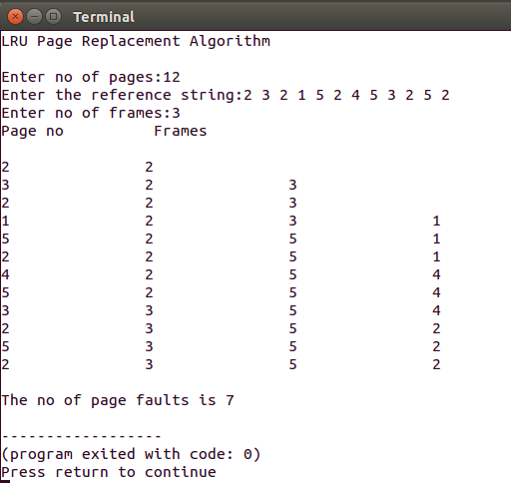

//Programmer Name: Sharvil Prabhudesai 20co41

//Program title : OPTIMAL

#include<stdio.h>

int main()

{

int no_of_frames, no_of_pages, frames[10], pages[30], temp[10], flag1, flag2, flag3, i,j, k, pos, max, faults = 0;

printf("Optimal Page Replacement Algorithm\n\n");

printf("Enter number of frames: ");

scanf("%d", &no_of_frames);

printf("Enter number of pages: ");

scanf("%d", &no_of_pages);

printf("Enter page reference string: ");

for(i = 0; i < no_of_pages; ++i){

scanf("%d", &pages[i]);

}

printf("Page no \t Frames\n");

for(i = 0; i < no_of_frames; ++i){

frames[i] =-1;

}

for(i = 0; i < no_of_pages; ++i){

flag1 = flag2 = 0;

for(j = 0; j < no_of_frames; ++j){

if(frames[j] == pages[i]){

flag1 = flag2 = 1;

break;

} }

if(flag1 == 0){

for(j = 0; j < no_of_frames; ++j){

if(frames[j] ==-1){

faults++;

frames[j] = pages[i];

flag2 = 1;

break; } } }

if(flag2 == 0){

flag3 =0;

for(j = 0; j < no_of_frames; ++j){

temp[j] =-1;

for(k = i + 1; k < no_of_pages; ++k){

if(frames[j] == pages[k]){

temp[j] = k;

break; } } }

for(j = 0; j < no_of_frames; ++j){

if(temp[j] ==-1){

pos = j;

flag3 = 1;

break; } }

if(flag3 ==0){

max = temp[0];

pos = 0;

for(j = 1; j < no_of_frames; ++j){

if(temp[j] > max){

max = temp[j];

pos = j; } } }

frames[pos] = pages[i];

faults++; }

printf("\n");

printf("%d\t\t",pages[i]);

for(j = 0; j < no_of_frames; ++j){

printf("%d\t", frames[j]); }

}

printf("\n\nTotal Page Faults = %d", faults);

return 0;

}

